Learning Project-1 Report

On

**“LIBRARY MANAGEMENT SYSTEM”**

Submitted in partial fulfillment of

The requirements for the 3rd Semester Sessional Examination of

BACHELOR OF TECHNOLOGY

IN

**COMPUTER SCIENCE & ENGINEERING**

By

**RAVJOT SINGH RAYAT**

**SOURAV THAKUR**

**PIYUSH DRATT PANDA**

**Registration No.**

**20UG010297**

**20UG010307**

**20UG010295**

**DEPARTMENT OF COMPUTER SCIENCE**

GIET UNIVERSITY, Gunupur

**GIET UNIVERSITY,GUNUPUR**

***Dist. - Rayagada, Odisha-765022,Contact:- +91 7735745535, 06857-250170,172, Visit us:-* www.giet.edu**

**Department of Computer Science & Engineering**

**CERTIFICATE**



**This is to certify that the project work entitled “Library Management System” is done by Ravjot Singh Rayat, Sourav Thakur and Piyush DrattPanda ,Regd. No.-20UG010297 20UG010307and 20UG01295 respectively in partial fulfillment of the requirements for the 3rd Semester Sessional Examination of Bachelor of Technology in Computer Science and Engineering during the academic year 2021-22. This work is submitted to the department as a part of evaluation of 3rdSemester Learning Project-1.**

Mr. Jagdsih Sahoo

Class Teacher

**ACKNOWLEDGEMENT**

I would like to thank my class teacher Mr.Jagdish Sahoo for providing ideas and inputs for project.

Secondly, I would like to thank our Project Coordinator Mr.Bhavani Sankar Panda for pushing to submit the project.

A special gratitude to our HOD Dr. Sanjay Kumar Kuanar, for being the guiding force in our B.Tech Journey.

Ravjot Singh Rayat 20UG010297

Sourav Thakur 20UG010307

Piyush DrattPanda 20UG010295

1

**ABSTRACT**

Library Management system is a project which aims in developing a computerized system to maintain all the daily work of library.

This Project has many features which are generally not available in normal library management system like facility of admin login through which the admin can monitor the whole system. The librarian after logging into his account can generate various options such as new student, new book , issue book and return book details.

Overall this project of ours is being developed to help staff of library to maintain the library in the best way possible and also reduce the human efforts.

2

**INTRODUCTION**

**1.1 Purpose**

The project titled **“Library Management System**” is a library management software for monitoring and controlling the transactions in the library.

The project “**Library Management System**”is developed by using HTML, CSS which mainly focuses on basic operations in a library like adding new member, new books, updating new information, searching books and returns book.

**1.2 Product Features**

* **We can add and remove books**
* **We can add and remove students**
* **We can update the list of books**

1. **System Analysis**
   1. **Hardware Requirements**

**Processor:** i3 or above.

**RAM:**2GB or above.

**Hard Disk:**5GB or above.

**Operating System:** Windows

* 1. **Software Used**
* **Visual Studio Code**
* **XAMP Server**
* **MY SQL**

3

**System Design & Specifications**

**ER Diagram**

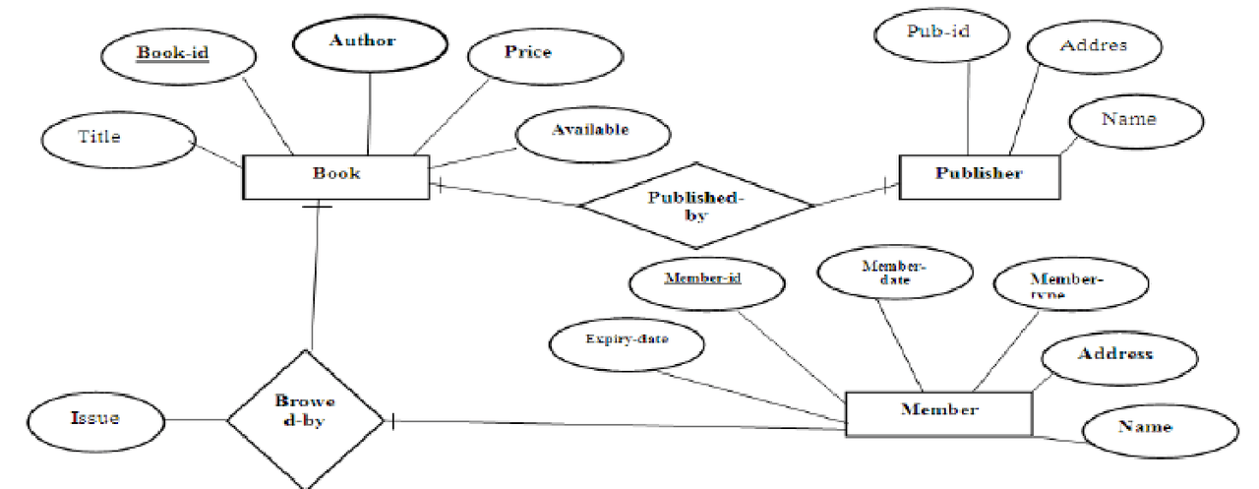

**4**

**Front End:**

<divclass="wrapper">

    <ul>

    <li>Student

    <ul><li><ahref="student/adds1.html"> Add student</a></li>

        <!--<li><a href="student/view1.php"> Remove Student</a></li> -->

        <li><ahref="student/view1.php"> View information</a></li>

        <!-- books/view.php -->

        </ul>

    <li><ahref="details/about.html "style="color: white;">About</a></li>

    <li>Books

<ul></li>

    <li><a href="books/adds.html">Add books</a></li>

     <li><a href="issue/issuebook.html">issue books</a></li>

    <li><a href="return/returnbook.html">return books</a></li>

    <li><a href="books/view.php">book info.</a></li>

    </ul>

    </li>

    <li><a href="contact/contact.html"style="color: white;"> Contact</a></li>

    <li><a href="./login.html" style="color: white;" >Exit</a></li>

</ul>

**5**

**Home Page--**

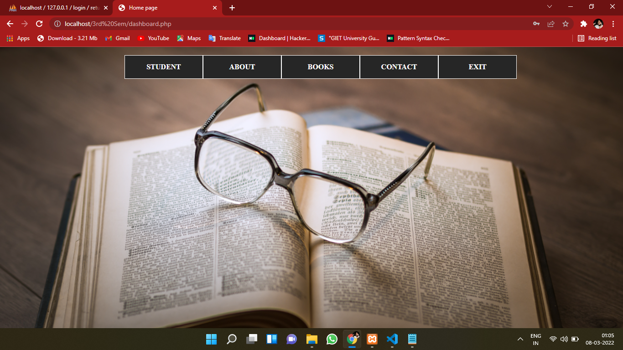

**6**

**Add Student –**

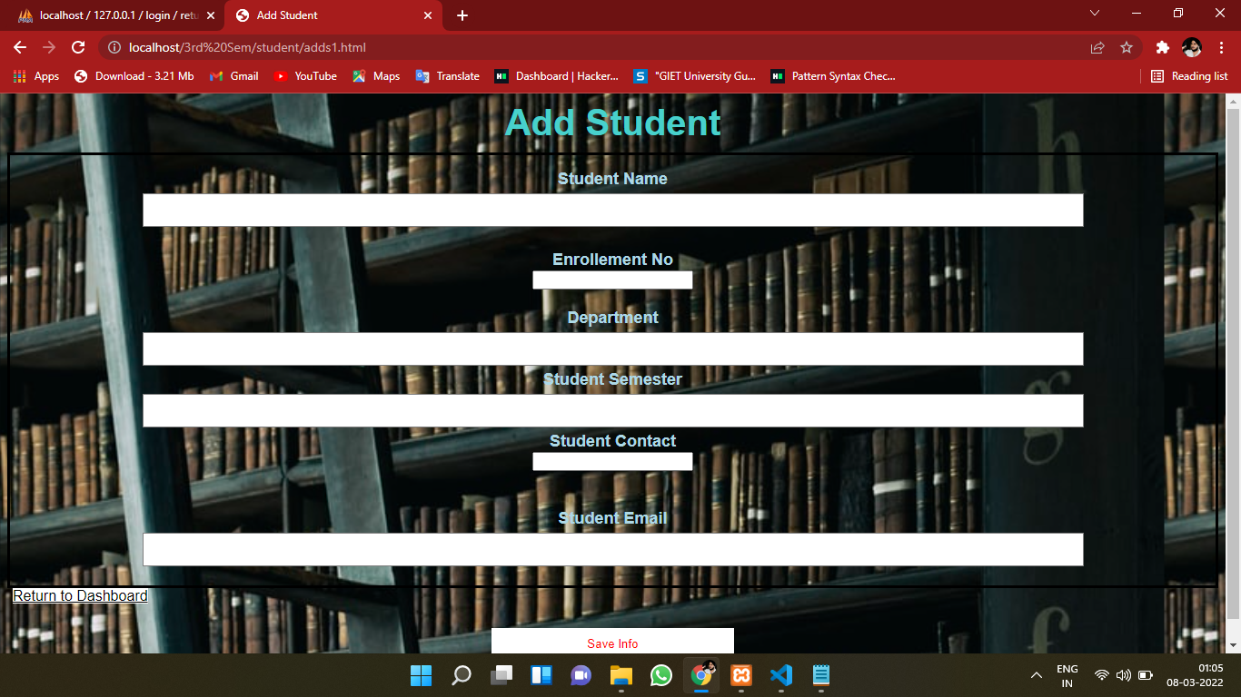

7

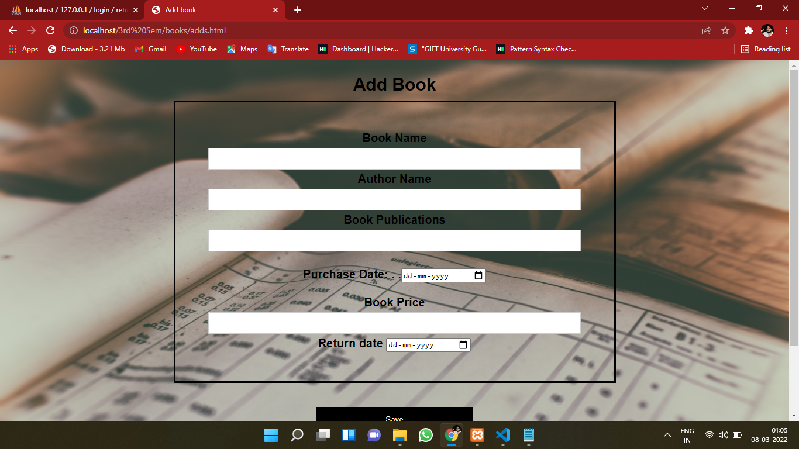**Add Book**

8

**Login Page**

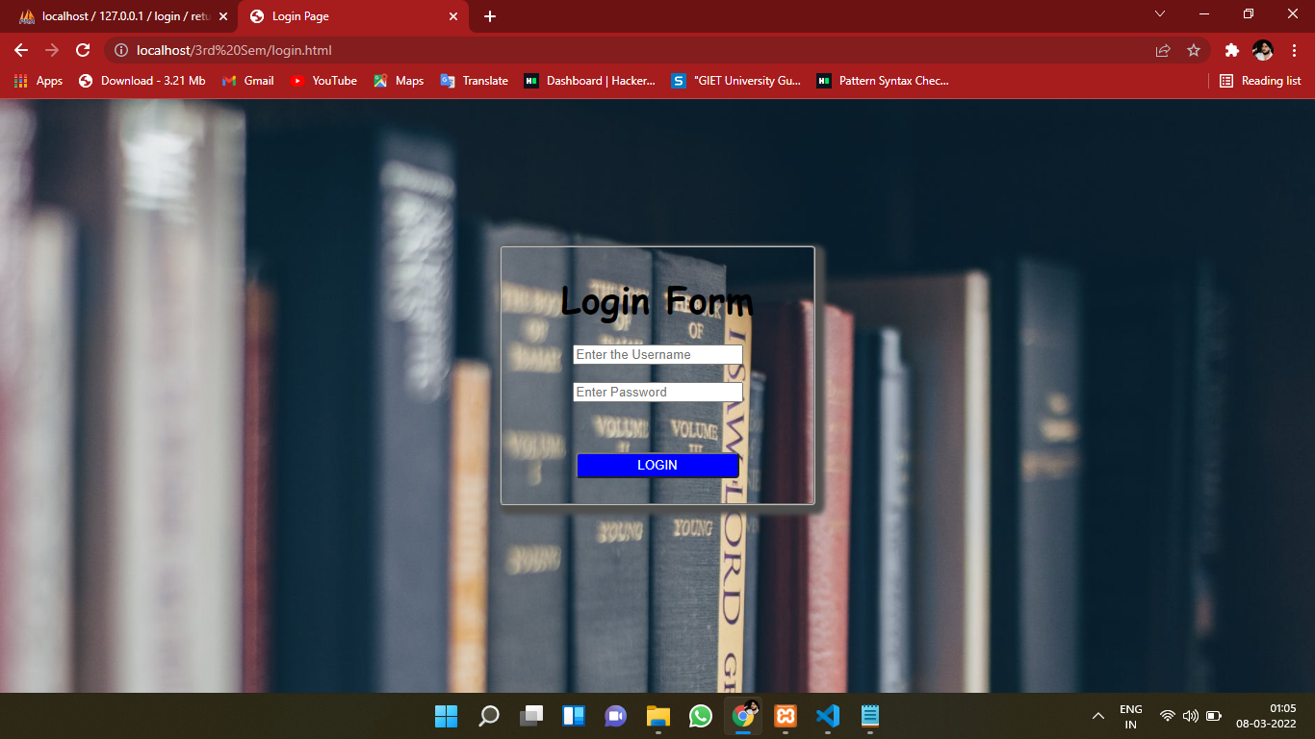

**9**

**Return book**

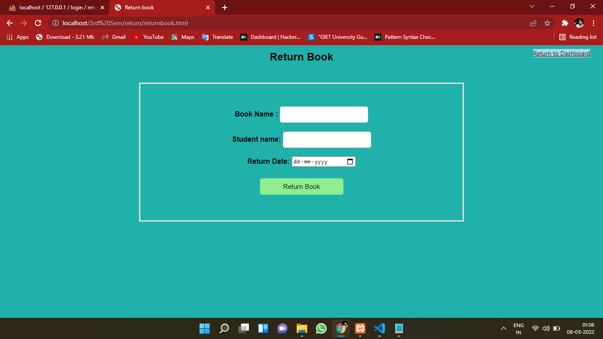

10

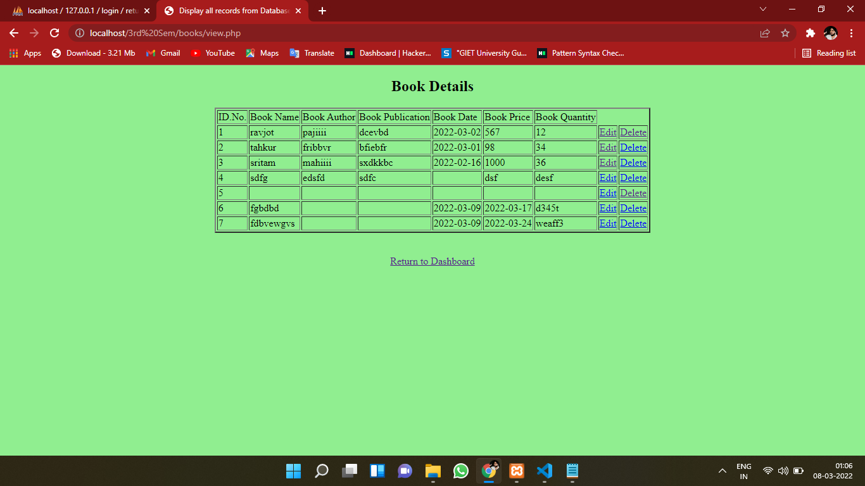**Book Details**

11

**Back-End code**

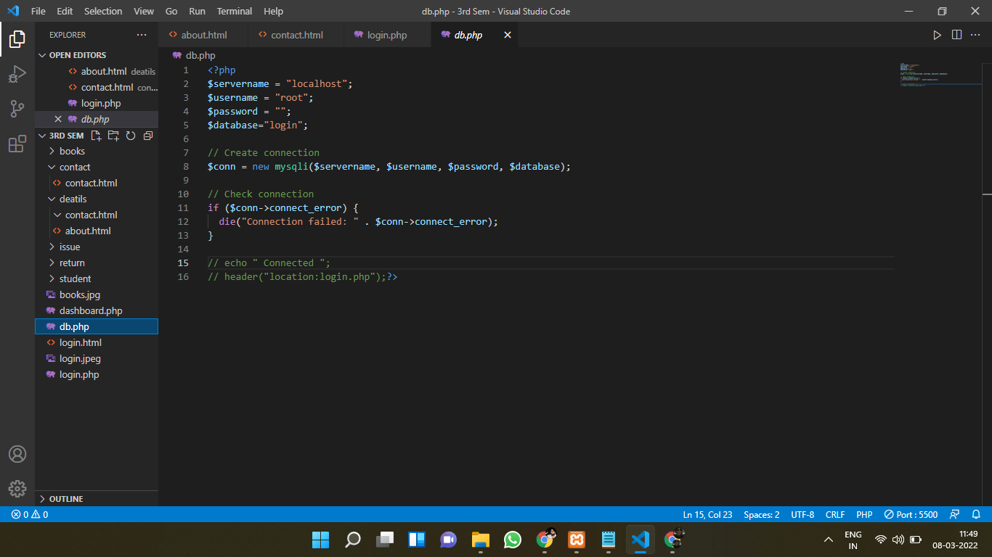

12

**REFERENCES**

[**https://www.w3schools.com/php/**](https://www.w3schools.com/php/)

[**https://www.w3schools.com/html/default.asp**](https://www.w3schools.com/html/default.asp)

[**https://www.w3schools.com/css/default.asp**](https://www.w3schools.com/css/default.asp)

**Experiences**

**Conclusion**

To conclude, I want to start by the mistakes and errors we made during the process of developing this application. We made a lot of errors, but managed to grasp a lot from those mistakes. This is a prototype model so a lot of errors are still present, which we want to rectify for a better future of the application.

**13**